**Cloud Federation**

Cloud Federation, also known as Federated Cloud is the deployment and management of several external and internal cloud computing services to match business needs. It is a multi-national cloud system that integrates private, community, and public clouds into scalable computing platforms. Federated cloud is created by connecting the cloud environment of different cloud providers using a common standard.

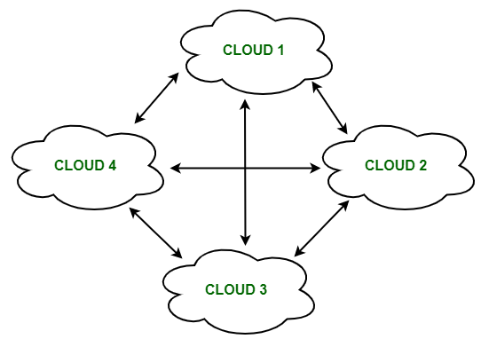

***Federated Cloud***

**The architecture of Federated Cloud:**

The architecture of Federated Cloud consists of three basic components:

**1. Cloud Exchange**

The Cloud Exchange acts as a mediator between cloud coordinator and cloud broker. The demands of the cloud broker are mapped by the cloud exchange to the available services provided by the cloud coordinator. The cloud exchange has a track record of what is the present cost, demand patterns, and available cloud providers, and this information is periodically reformed by the cloud coordinator.

**2. Cloud Coordinator**

The cloud coordinator assigns the resources of the cloud to the remote users based on the quality of service they demand and the credits they have in the cloud bank. The cloud enterprises and their membership are managed by the cloud controller.

**3. Cloud Broker**

The cloud broker interacts with the cloud coordinator, analyzes the Service-level agreement and the resources offered by several cloud providers in cloud exchange. Cloud broker finalizes the most suitable deal for their client.

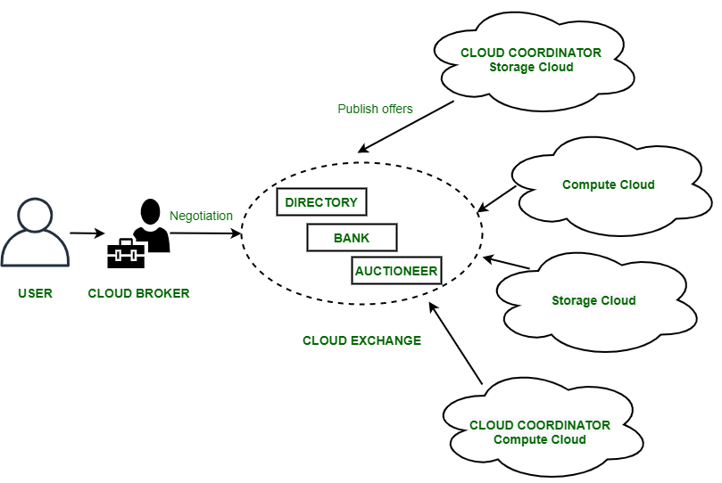

***Federal Cloud Architecture***

**Properties of Federated Cloud:**

1. In the federated cloud, the users can interact with the architecture either centrally or in a decentralized manner. In centralized interaction, the user interacts with a broker to mediate between them and the organization. Decentralized interaction permits the user to interact directly with the clouds in the federation.
2. Federated cloud can be practiced with various niches like commercial and non-commercial.
3. The visibility of a federated cloud assists the user to interpret the organization of several clouds in the federated environment.
4. Federated cloud can be monitored in two ways. MaaS (Monitoring as a Service) provides information that aids in tracking contracted services to the user. Global monitoring aids in maintaining the federated cloud.
5. The providers who participate in the federation publish their offers to a central entity. The user interacts with this central entity to verify the prices and propose an offer.
6. The marketing objects like infrastructure, software, and platform have to pass through federation when consumed in the federated cloud.

**Benefits of Federated Cloud:**

1. It increases reliability.
2. It minimizes the time and cost of providers due to dynamic scalability.
3. It connects various cloud service providers globally. The providers may buy and sell services on demand.
4. It provides easy scaling up of resources.

**Challenges in Federated Cloud:**

1. In cloud federation, it is common to have more than one provider for processing the incoming demands. In such cases, there must be a scheme needed to distribute the incoming demands equally among the cloud service providers.
2. The increasing requests in cloud federation have resulted in more heterogeneous infrastructure, making interoperability an area of concern. It becomes a challenge for cloud users to select relevant cloud service providers and therefore, it ties them to a particular cloud service provider.
3. A federated cloud means constructing a seamless cloud environment that can interact with people, different devices, several application interfaces, and other entities.

**Federated Cloud technologies:**

The technologies that aid the cloud federation and cloud services are:

**1. OpenNebula**

It is a cloud computing platform for managing heterogeneous distributed data center infrastructures. It can use the resources of its interoperability, leveraging existing information technology assets, protecting the deals, and adding the application programming interface (API).

**2. Aneka coordinator**

The Aneka coordinator is a proposition of the Aneka services and Aneka peer components (network architectures) which give the cloud ability and performance to interact with other cloud services.

**3. Eucalyptus**

Eucalyptus defines the pooling computational, storage, and network resources that can be measured scaled up or down as application workloads change in the utilization of the software. It is an open-source framework that performs the storage, network, and many other computational resources to access the cloud environment.